# Exercises: Introduction to Databases

## Create New Database

* Connect to Server with Authentication Mode

* Create a new database

* Type the name of the database and click OK. This will create your database.

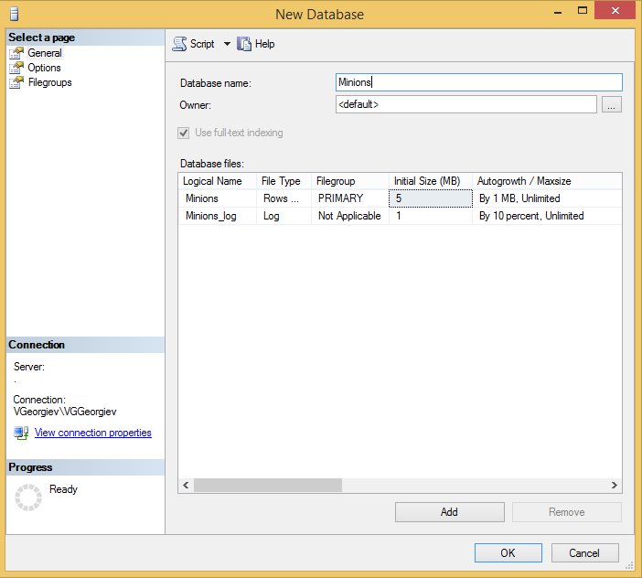

## Create Table

* Create **table** **Minions**

* Create columns **Id, Name, Age**. Id and Name are **required**; Age should **allow null values**.

* Set the **Id** as **primary key**.

## Insert Data in the Table

Insert data in the table as its show on the picture

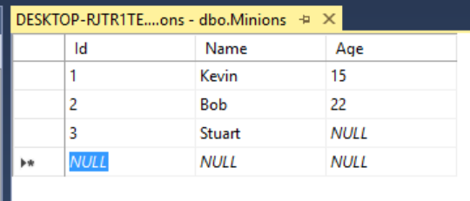

## Select Data from Table

* Select all columns from the Minions table.

* Open new query window, then write the SQL.
  + * Select **only Names** from Minions table.
  + ** **Order** them **ascending by name**

## Update One Record

Change **Stuart’s age** from **NULL** to **10**

## Update All Records

Change all of the Minions age to be + 1 years.

## Delete Record

Open table in the Edit Mode, **right click** on the row where **Bob** is situated and delete it.

## Create New Table

Create new table **Towns**. Every town has **Id (int)** and **Name (text)**. Make the **Id** column **primary key**.

## *Connect Tables

Now let’s make a connection (or relationship) between our two tables. First we need modify our Minions table. Add column **TownId** in it **(IMPORTANT: The type of the column must be the same as the type of the column Id of the Towns table)**.

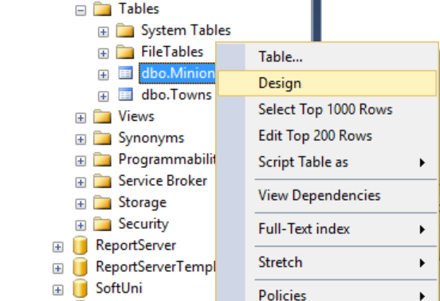

Now we can make new diagram. The diagram shows all tables and the relationships between them.

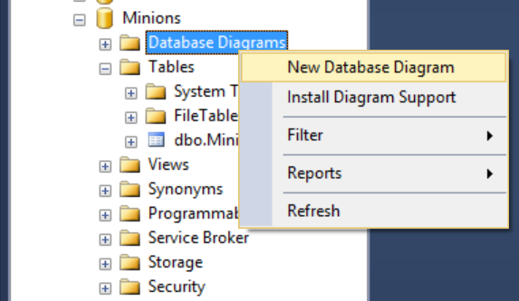

Select all tables to be on the diagram and click **Add**

Finally, simply drag the **TownId** column and drop it on the Id column in Towns. Then Make sure the window looks like this and click OK.

That’s all. Now the two tables have a relationship between them.

## Create New Database

Now on your own create a new database **School**. Add a few tables to the database: **Students (Id, Name, Age, PhoneNumber)**, **Classes (Id, Name, MaxStudents), Teachers(Id, Name, Class)**. Add columns for the tables. Populate the tables with random content. Then delete and make changes in some records.

## *Generate SQL Script

Generate SQL script from the **School** database. View the script file and try to understand different commands. Execute the script.